Table of Contents
1 Heading 1 2
1.1 Heading 1.1 2
1.1.1 Heading 1.1.1 2

Database Connection Profile
Windows → References
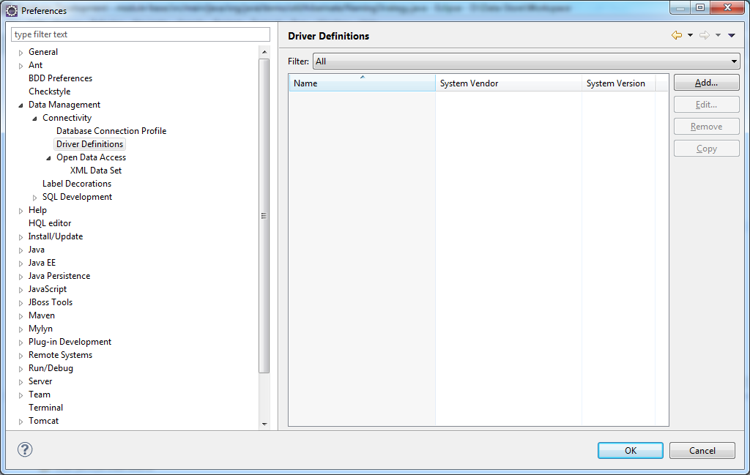
Click [Add] button
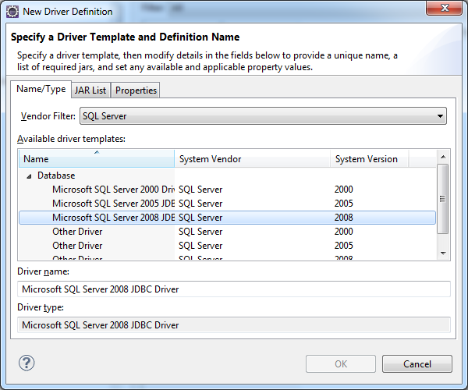

Create Project

Create Maven project
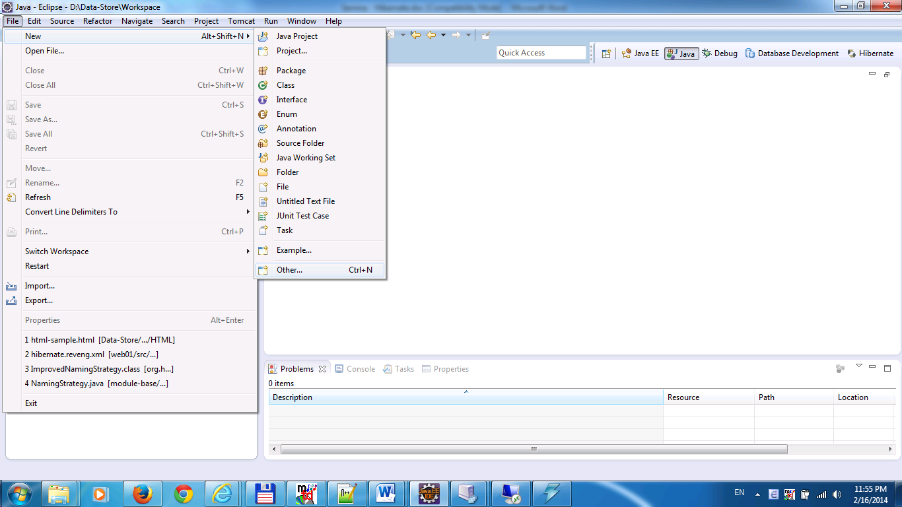
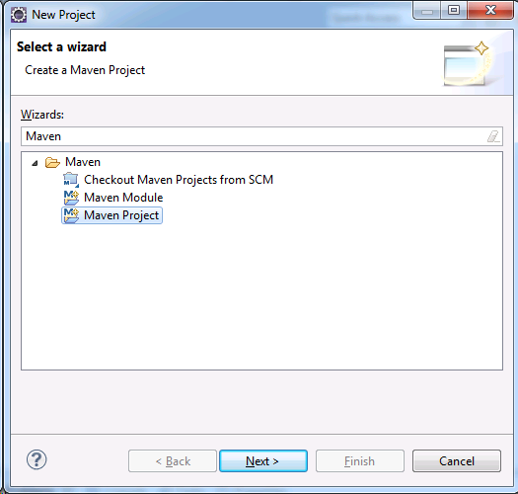
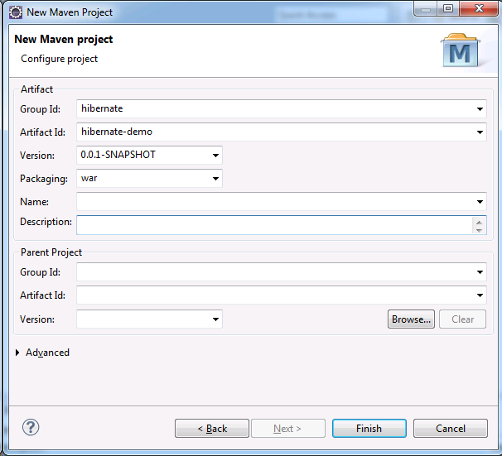

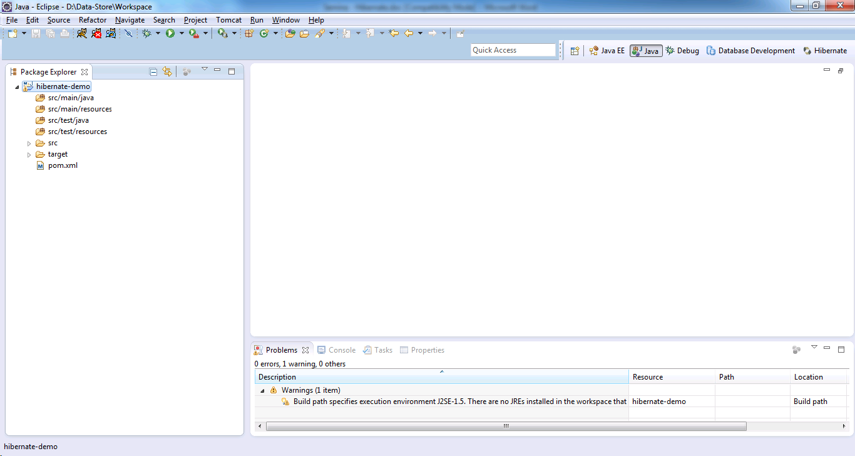

Add libraries

Create DB config
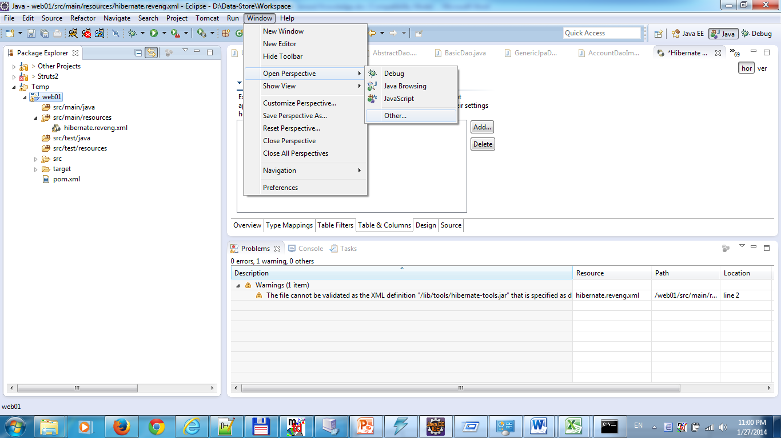

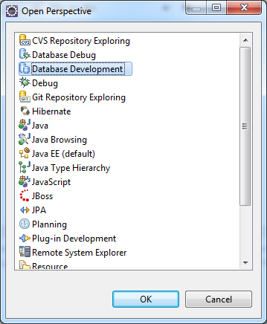

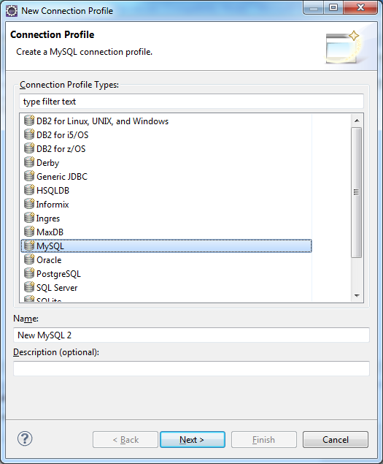

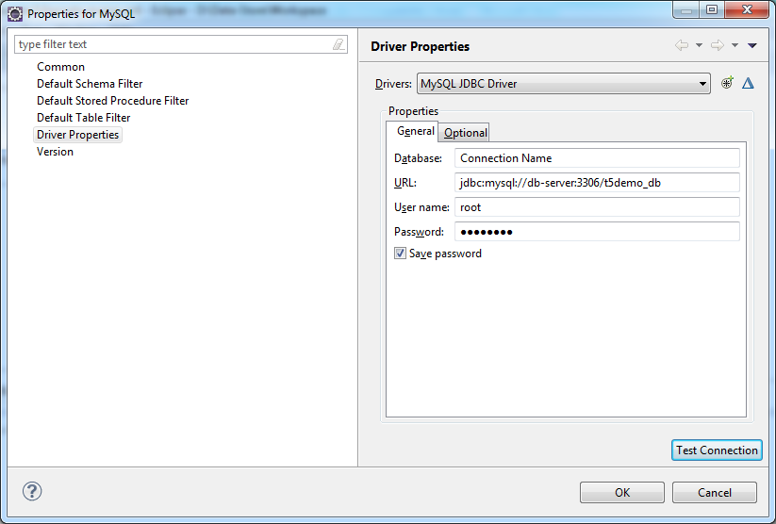

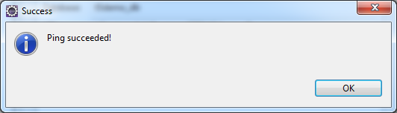

Hibernate Console Configuration
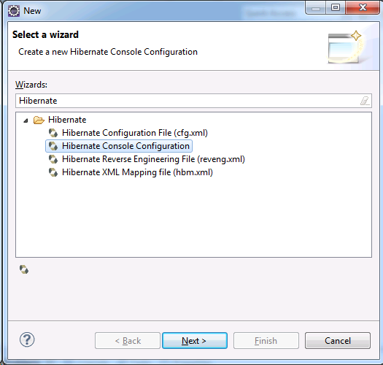
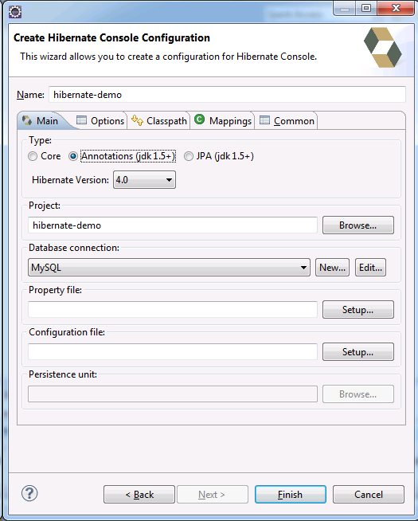

Hibernate Configuration File
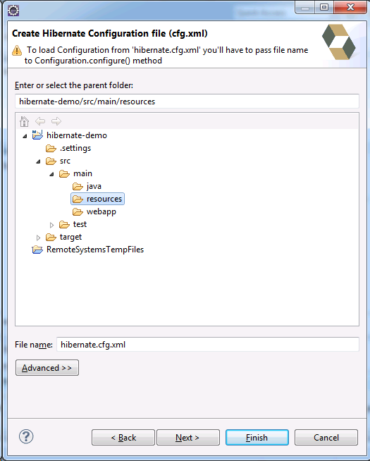
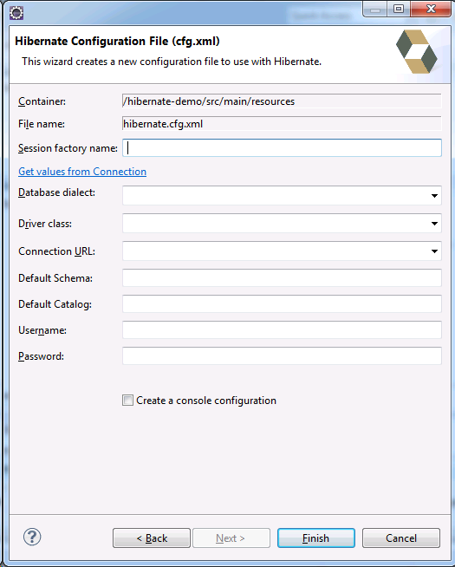
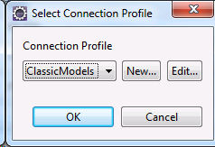
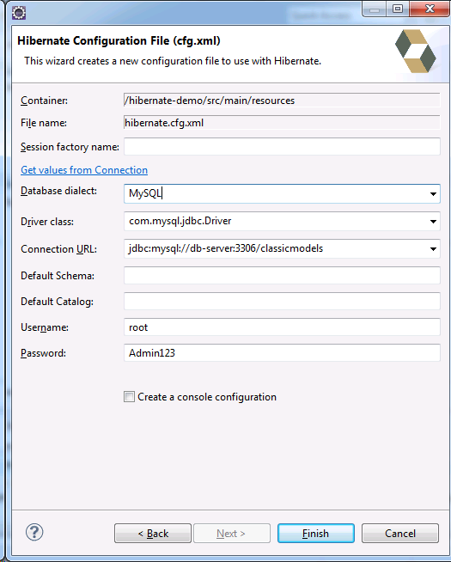

Hibernate Reverse Engineering File
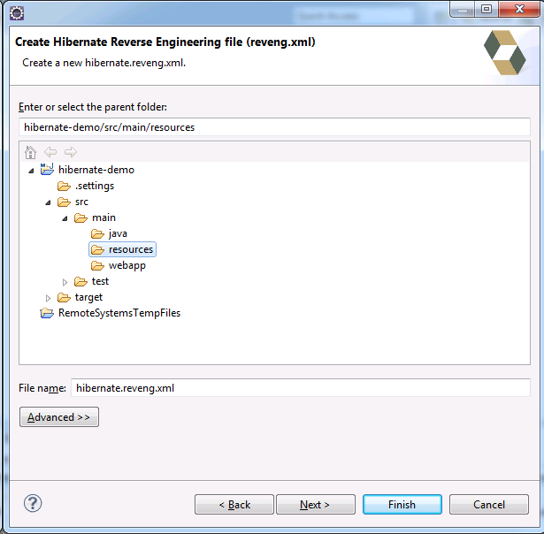

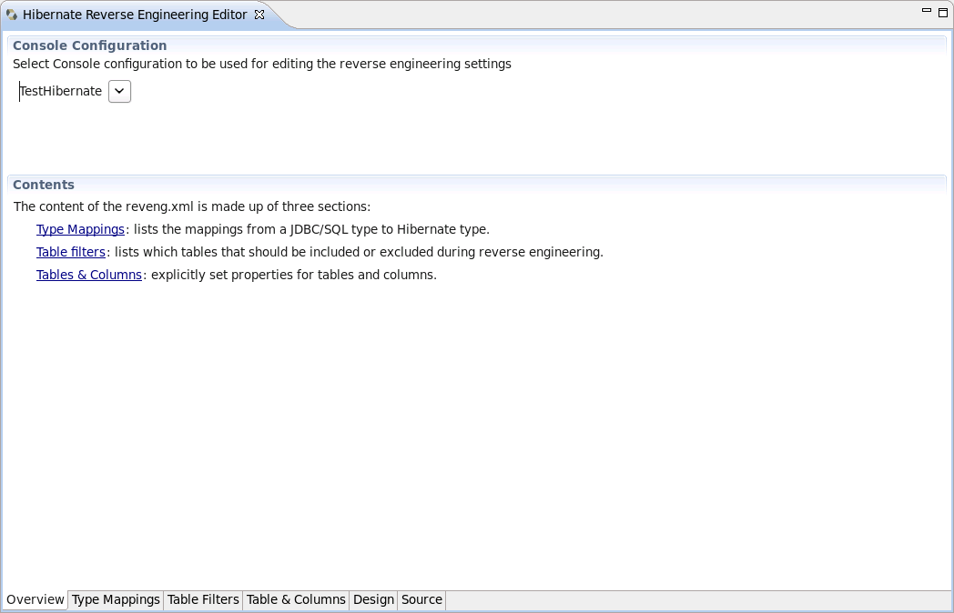

Table Filter page
The Table Filter page allows you to specify which tables to include and exclude. Clicking the Refresh button shows the tables from the database that have not yet been excluded
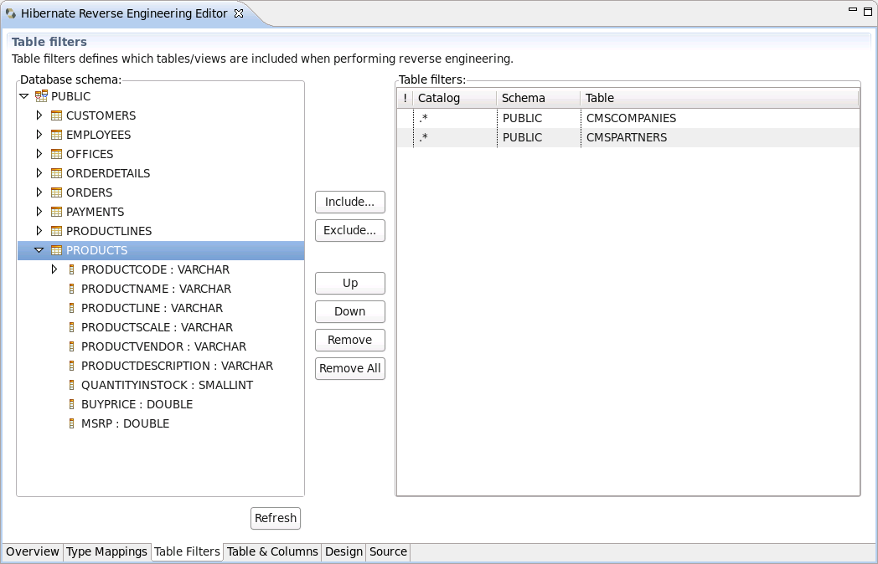

Type Mappings page
The Type Mappings page is used to specify type mappings from JBDC types to any Hibernate type (including user types) if the default rules are not applicable
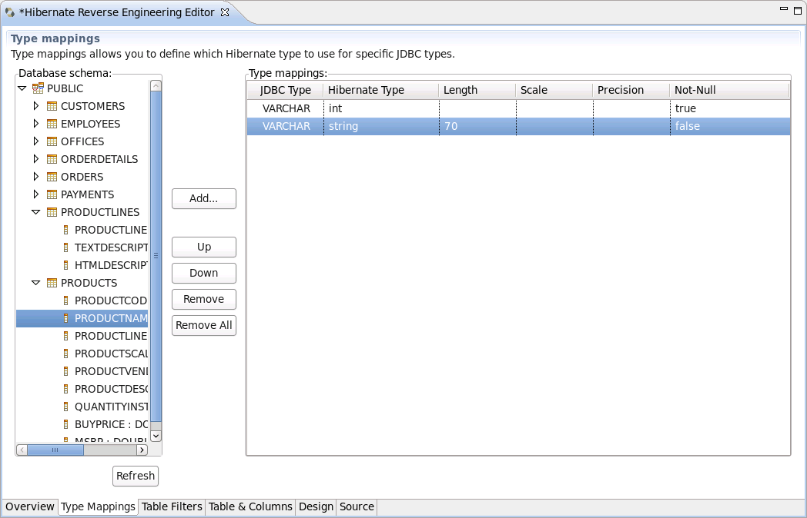

Hibernate Code Generation Configurations
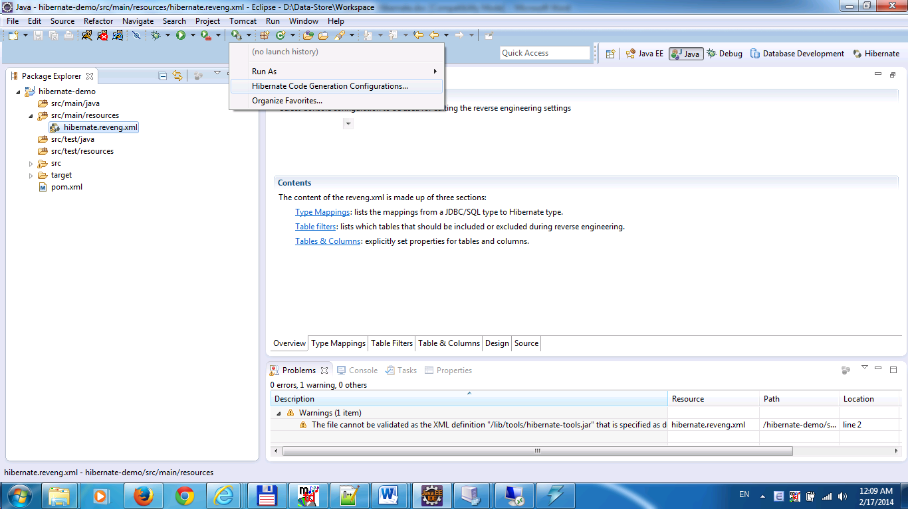
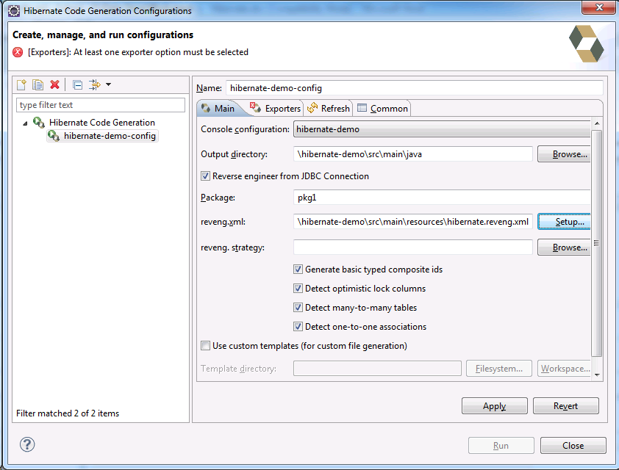
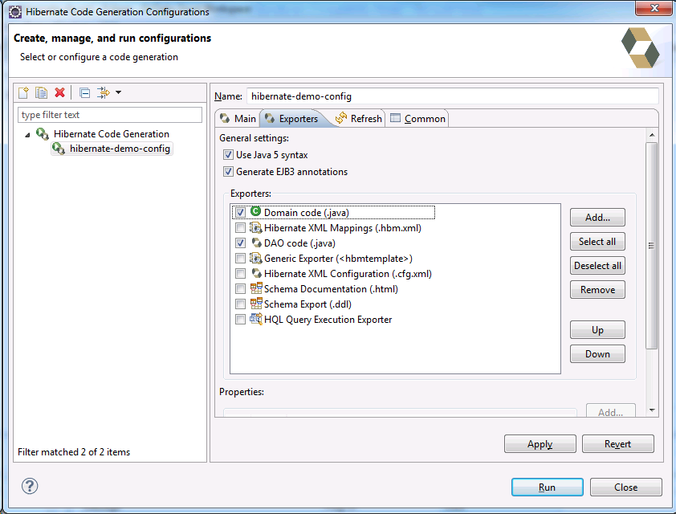

Generate Code

References
- Hibernate tool: http://docs.jboss.org/tools/4.0.1.Final/en/hibernatetools/html_single
- http://omtlab.com/java-hibernate-reverse-engineering-eclipse-tutorial

